**SCHOOL OF COMPUTER SCIENCE**

**UNIVERSITY OF PETROLEUM AND ENERGY STUDIES**

**DEHRADUN, UTTARAKHAND**



**COMPUTER GRAPHICS**

**LABORATORY FILE**

**(2024-2025)**

**For**

**Vth Semester**

**Submitted To: Submitted By:**

Mr. Dinesh Akshat Negi

Assistant Professor 500106533(SAP ID)

[Vth Semester] R2142220414(Roll No.)

School of Computer Science B.Tech. CSF (Batch-1)

**LAB EXPERIMENT – 4**

**Seed Fill Algorithms**

**[Small Project will be given for demonstration]**

***# Take the value of seed point, intensity of new color as input from user.***

1. WAP to fill the polygon using scan lines.

#include <GL/freeglut.h>

#include <iostream>

#include <vector>

#include <algorithm>

// Global Variables

std::vector<int> x_coords;

std::vector<int> y_coords;

int edges;

// Function to draw a line between two points

void drawLine(int x1, int y1, int x2, int y2) {

glBegin(GL_LINES);

glVertex2i(x1, y1);

glVertex2i(x2, y2);

glEnd();

glFlush();

}

// Function to implement scan-line polygon filling

void scanFill()

{

int i, j, temp;

int xmin = *std::min_element(x_coords.begin(), x_coords.end());

int xmax = *std::max_element(x_coords.begin(), x_coords.end());

// Scan each scan-line within the polygon's vertical extent

for (i = xmin; i <= xmax; i++) {

// Initialize an array to store the intersection points

std::vector<int> interPoints;

for (j = 0; j < edges; j++) {

int next = (j + 1) % edges;

// Check if the current edge intersects with the scan line

if ((y_coords[j] > i && y_coords[next] <= i) || (y_coords[next] > i && y_coords[j] <= i)) {

int interX = x_coords[j] + (i - y_coords[j]) * (x_coords[next] - x_coords[j]) / (y_coords[next] - y_coords[j]);

interPoints.push_back(interX);

}

}

// Sort the intersection points in ascending order

std::sort(interPoints.begin(), interPoints.end());

// Fill the pixels between pairs of intersection points

for (j = 0; j < interPoints.size(); j += 2) {

if (j + 1 < interPoints.size()) {

drawLine(interPoints[j], i, interPoints[j + 1], i);

}

}

}

}

// Display callback for OpenGL

void display() {

glClear(GL_COLOR_BUFFER_BIT);

scanFill();

glFlush();

}

// Function to initialize OpenGL

void init() {

// Set the background color to white and the drawing color to black

glClearColor(1.0, 1.0, 1.0, 1.0);

glColor3f(0.0, 0.0, 0.0);

// Set up 2D orthographic projection with the window size

glMatrixMode(GL_PROJECTION);

gluOrtho2D(0.0, 500.0, 0.0, 500.0); // Adjust window size as needed

}

int main(int argc, char** argv) {

// Define the polygon vertices

x_coords = { 100, 200, 300 };

y_coords = { 100, 300, 200 };

edges = 3;

// Initialize GLUT

glutInit(&argc, argv);

glutInitDisplayMode(GLUT_SINGLE | GLUT_RGB);

glutInitWindowSize(500, 500); // Window size

glutInitWindowPosition(100, 100);

glutCreateWindow("Scan-Line Polygon Fill - Akshat Negi");

init(); // Set up OpenGL

// Register the display callback function

glutDisplayFunc(display);

// Enter the GLUT main loop

glutMainLoop();

return 0;

}

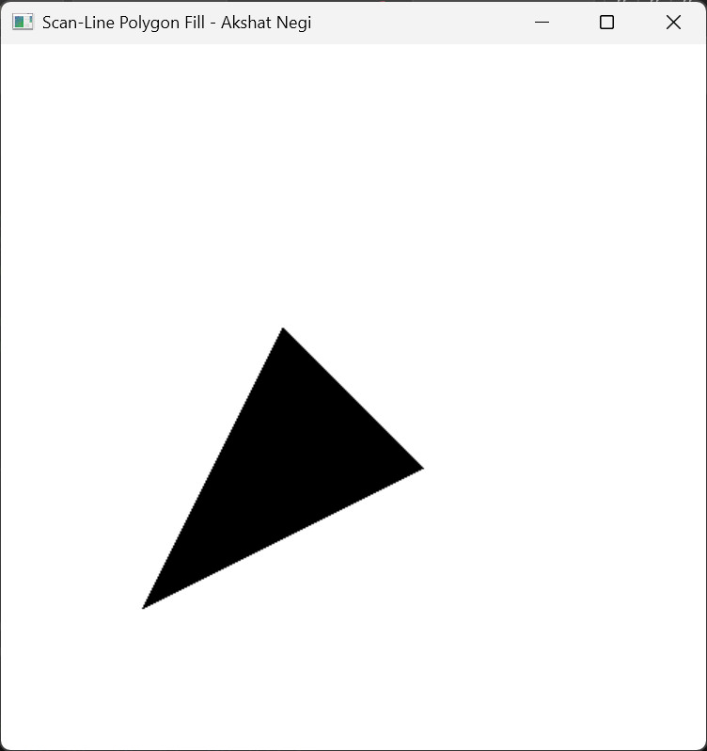

1. WAP to fill a region using boundary fill algorithm using 4 or 8 connected approaches.

#include <GL/freeglut.h>

#include <iostream>

#include <cmath>

float fillColor[3] = { 1.0, 0.0, 0.0 }; // Red color for filling

float borderColor[3] = { 0.0, 0.0, 0.0 }; // Black color for the boundary

float epsilon = 0.001; // Tolerance for color comparison

// Function to set a pixel with a specific color

void setPixel(int x, int y, float* color) {

glColor3fv(color);

glBegin(GL_POINTS);

glVertex2i(x, y);

glEnd();

glFlush();

}

// Function to get the color of a pixel at coordinates (x, y)

void getPixelColor(int x, int y, float* color) {

glReadPixels(x, y, 1, 1, GL_RGB, GL_FLOAT, color);

}

// Helper function to compare two colors with a tolerance

bool isSameColor(float* color1, float* color2) {

return (fabs(color1[0] - color2[0]) < epsilon &&

fabs(color1[1] - color2[1]) < epsilon &&

fabs(color1[2] - color2[2]) < epsilon);

}

// Boundary Fill Algorithm (8-connected)

void boundaryFill(int x, int y, float* fillColor, float* boundaryColor) {

float currentColor[3];

getPixelColor(x, y, currentColor);

// If the pixel is neither the boundary nor the fill color, fill it

if (!isSameColor(currentColor, boundaryColor) && !isSameColor(currentColor, fillColor)) {

setPixel(x, y, fillColor);

// 8-connected neighbors

boundaryFill(x + 1, y, fillColor, boundaryColor); // Right

boundaryFill(x - 1, y, fillColor, boundaryColor); // Left

boundaryFill(x, y + 1, fillColor, boundaryColor); // Up

boundaryFill(x, y - 1, fillColor, boundaryColor); // Down

boundaryFill(x + 1, y + 1, fillColor, boundaryColor); // Up-Right

boundaryFill(x - 1, y + 1, fillColor, boundaryColor); // Up-Left

boundaryFill(x + 1, y - 1, fillColor, boundaryColor); // Down-Right

boundaryFill(x - 1, y - 1, fillColor, boundaryColor); // Down-Left

}

}

// Function to draw a smaller triangle

void drawTriangle() {

glColor3fv(borderColor); // Set border color (black)

glBegin(GL_LINE_LOOP);

glVertex2i(120, 150); // Top vertex

glVertex2i(100, 100); // Bottom-left vertex

glVertex2i(140, 100); // Bottom-right vertex

glEnd();

glFlush();

}

void display() {

glClear(GL_COLOR_BUFFER_BIT);

drawTriangle(); // Draw triangle on screen

// Starting the boundary fill from a point inside the triangle

boundaryFill(120, 120, fillColor, borderColor);

}

void init() {

glClearColor(1.0, 1.0, 1.0, 1.0); // Set background color to white

glColor3f(0.0, 0.0, 0.0); // Set drawing color to black

gluOrtho2D(0, 300, 0, 300); // Set the coordinate system for the window

}

int main(int argc, char** argv) {

glutInit(&argc, argv);

glutInitDisplayMode(GLUT_SINGLE | GLUT_RGB);

glutInitWindowSize(300, 300); // Decrease window size

glutInitWindowPosition(100, 100);

glutCreateWindow("Boundary Fill - 8 Connected Triangle - Akshat Negi");

init();

glutDisplayFunc(display);

glutMainLoop();

return 0;

}

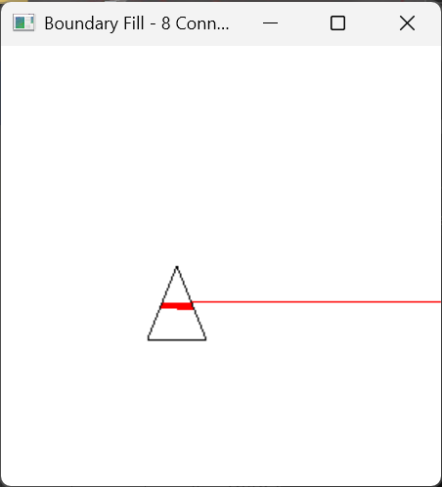

#include <GL/freeglut.h>

#include <iostream>

#include <cmath>

float fillColor[3] = { 1.0, 0.0, 0.0 }; // Red color for filling

float borderColor[3] = { 0.0, 0.0, 0.0 }; // Black color for the boundary

float epsilon = 0.001; // Tolerance for color comparison

// Function to set a pixel with a specific color

void setPixel(int x, int y, float* color) {

glColor3fv(color);

glBegin(GL_POINTS);

glVertex2i(x, y);

glEnd();

glFlush();

}

// Function to get the color of a pixel at coordinates (x, y)

void getPixelColor(int x, int y, float* color) {

glReadPixels(x, y, 1, 1, GL_RGB, GL_FLOAT, color);

}

// Helper function to compare two colors with a tolerance

bool isSameColor(float* color1, float* color2) {

return (fabs(color1[0] - color2[0]) < epsilon &&

fabs(color1[1] - color2[1]) < epsilon &&

fabs(color1[2] - color2[2]) < epsilon);

}

// Boundary Fill Algorithm (4-connected)

void boundaryFill(int x, int y, float* fillColor, float* boundaryColor) {

float currentColor[3];

getPixelColor(x, y, currentColor);

// If the pixel is neither the boundary nor the fill color, fill it

if (!isSameColor(currentColor, boundaryColor) && !isSameColor(currentColor, fillColor)) {

setPixel(x, y, fillColor);

boundaryFill(x + 1, y, fillColor, boundaryColor);

boundaryFill(x - 1, y, fillColor, boundaryColor);

boundaryFill(x, y + 1, fillColor, boundaryColor);

boundaryFill(x, y - 1, fillColor, boundaryColor);

}

}

// Function to draw a triangle

void drawTriangle() {

glColor3fv(borderColor); // Set border color (black)

glBegin(GL_LINE_LOOP);

glVertex2i(50, 50); // Vertex 1 (Bottom-left corner)

glVertex2i(100, 50); // Vertex 2 (Bottom-right corner)

glVertex2i(75, 100); // Vertex 3 (Top corner)

glEnd();

glFlush();

}

void display() {

glClear(GL_COLOR_BUFFER_BIT);

drawTriangle(); // Draw triangle on screen

// Starting the boundary fill from a point inside the triangle

boundaryFill(75, 60, fillColor, borderColor); // Adjusted point for filling

}

void init() {

glClearColor(1.0, 1.0, 1.0, 1.0); // Set background color to white

glColor3f(0.0, 0.0, 0.0); // Set drawing color to black

gluOrtho2D(0, 500, 0, 500); // Set the coordinate system for the window

}

int main(int argc, char** argv) {

glutInit(&argc, argv);

glutInitDisplayMode(GLUT_SINGLE | GLUT_RGB);

glutInitWindowSize(500, 500);

glutInitWindowPosition(100, 100);

glutCreateWindow("Boundary Fill - Triangle - Akshat Negi");

init();

glutDisplayFunc(display);

glutMainLoop();

return 0;

}

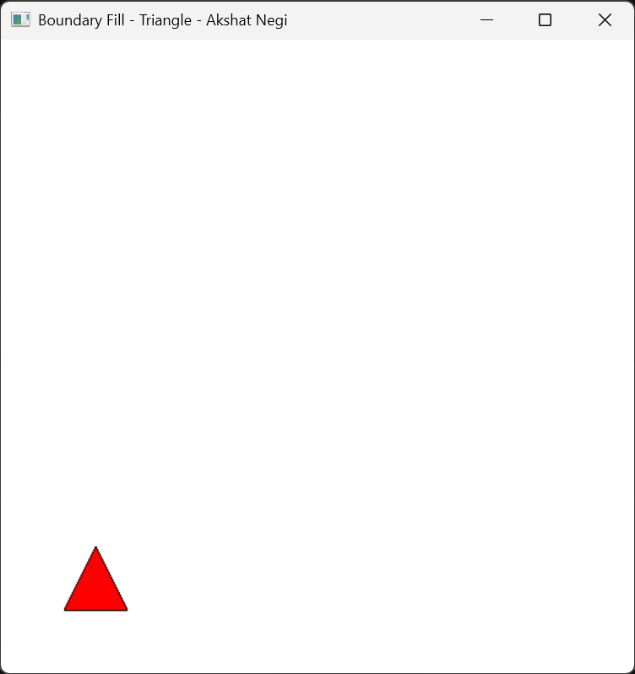

1. WAP to fill a region using flood fill algorithm using 4 or 8 connected approaches.

#include <GL/freeglut.h>

#include <iostream>

#include <cmath>

float fillColor[3] = { 1.0, 0.0, 0.0 }; // Red color for filling

float borderColor[3] = { 0.0, 0.0, 0.0 }; // Black color for the boundary

float epsilon = 0.001; // Tolerance for color comparison

// Function to set a pixel with a specific color

void setPixel(int x, int y, float* color) {

glColor3fv(color);

glBegin(GL_POINTS);

glVertex2i(x, y);

glEnd();

glFlush();

}

// Function to get the color of a pixel at coordinates (x, y)

void getPixelColor(int x, int y, float* color) {

glReadPixels(x, y, 1, 1, GL_RGB, GL_FLOAT, color);

}

// Helper function to compare two colors with a tolerance

bool isSameColor(float* color1, float* color2) {

return (fabs(color1[0] - color2[0]) < epsilon &&

fabs(color1[1] - color2[1]) < epsilon &&

fabs(color1[2] - color2[2]) < epsilon);

}

// 4-Connected Flood Fill Algorithm

void floodFill(int x, int y, float* fillColor, float* boundaryColor) {

float currentColor[3];

getPixelColor(x, y, currentColor);

// If the pixel is neither the boundary nor the fill color, fill it

if (!isSameColor(currentColor, boundaryColor) && !isSameColor(currentColor, fillColor)) {

setPixel(x, y, fillColor);

// 4-connected neighbors

floodFill(x + 1, y, fillColor, boundaryColor); // Right

floodFill(x - 1, y, fillColor, boundaryColor); // Left

floodFill(x, y + 1, fillColor, boundaryColor); // Up

floodFill(x, y - 1, fillColor, boundaryColor); // Down

}

}

// Function to draw a smaller triangle

void drawTriangle() {

glColor3fv(borderColor); // Set border color (black)

glBegin(GL_LINE_LOOP);

glVertex2i(120, 150); // Top vertex

glVertex2i(100, 100); // Bottom-left vertex

glVertex2i(140, 100); // Bottom-right vertex

glEnd();

glFlush();

}

void display() {

glClear(GL_COLOR_BUFFER_BIT);

drawTriangle(); // Draw triangle on screen

// Starting the flood fill from a point inside the triangle

floodFill(120, 120, fillColor, borderColor);

}

void init() {

glClearColor(1.0, 1.0, 1.0, 1.0); // Set background color to white

glColor3f(0.0, 0.0, 0.0); // Set drawing color to black

gluOrtho2D(0, 300, 0, 300); // Set the coordinate system for the window

}

int main(int argc, char** argv) {

glutInit(&argc, argv);

glutInitDisplayMode(GLUT_SINGLE | GLUT_RGB);

glutInitWindowSize(300, 300); // Decrease window size

glutInitWindowPosition(100, 100);

glutCreateWindow("Flood Fill - 4 Connected Triangle – Akshat Negi");

init();

glutDisplayFunc(display);

glutMainLoop();

return 0;

}

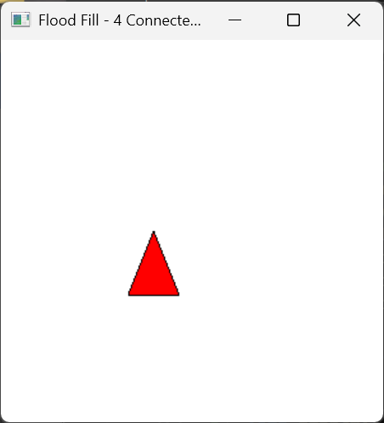

#include <GL/freeglut.h>

#include <iostream>

#include <cmath>

float fillColor[3] = { 1.0, 0.0, 0.0 }; // Red color for filling

float borderColor[3] = { 0.0, 0.0, 0.0 }; // Black color for the boundary

float epsilon = 0.001; // Tolerance for color comparison

// Function to set a pixel with a specific color

void setPixel(int x, int y, float* color) {

glColor3fv(color);

glBegin(GL_POINTS);

glVertex2i(x, y);

glEnd();

glFlush();

}

// Function to get the color of a pixel at coordinates (x, y)

void getPixelColor(int x, int y, float* color) {

glReadPixels(x, y, 1, 1, GL_RGB, GL_FLOAT, color);

}

// Helper function to compare two colors with a tolerance

bool isSameColor(float* color1, float* color2) {

return (fabs(color1[0] - color2[0]) < epsilon &&

fabs(color1[1] - color2[1]) < epsilon &&

fabs(color1[2] - color2[2]) < epsilon);

}

// Flood Fill Algorithm (8-connected)

void floodFill(int x, int y, float* fillColor, float* boundaryColor) {

float currentColor[3];

getPixelColor(x, y, currentColor);

// If the pixel is neither the boundary nor the fill color, fill it

if (!isSameColor(currentColor, boundaryColor) && !isSameColor(currentColor, fillColor)) {

setPixel(x, y, fillColor);

// Recursively call floodFill for 8-connected neighbors

floodFill(x + 1, y, fillColor, boundaryColor); // Right

floodFill(x - 1, y, fillColor, boundaryColor); // Left

floodFill(x, y + 1, fillColor, boundaryColor); // Up

floodFill(x, y - 1, fillColor, boundaryColor); // Down

floodFill(x + 1, y + 1, fillColor, boundaryColor); // Top-Right

floodFill(x - 1, y - 1, fillColor, boundaryColor); // Bottom-Left

floodFill(x + 1, y - 1, fillColor, boundaryColor); // Bottom-Right

floodFill(x - 1, y + 1, fillColor, boundaryColor); // Top-Left

}

}

// Function to draw a triangle

void drawTriangle() {

glColor3fv(borderColor); // Set border color (black)

glBegin(GL_LINE_LOOP);

glVertex2i(250, 400); // Top vertex

glVertex2i(150, 200); // Bottom-left vertex

glVertex2i(350, 200); // Bottom-right vertex

glEnd();

glFlush();

}

void display() {

glClear(GL_COLOR_BUFFER_BIT);

drawTriangle(); // Draw triangle on screen

// Starting the flood fill from a point inside the triangle

floodFill(250, 250, fillColor, borderColor);

}

void init() {

glClearColor(1.0, 1.0, 1.0, 1.0); // Set background color to white

glColor3f(0.0, 0.0, 0.0); // Set drawing color to black

gluOrtho2D(0, 500, 0, 500); // Set the coordinate system for the window

}

int main(int argc, char** argv) {

glutInit(&argc, argv);

glutInitDisplayMode(GLUT_SINGLE | GLUT_RGB);

glutInitWindowSize(500, 500);

glutInitWindowPosition(100, 100);

glutCreateWindow("8-Connected Flood Fill - Triangle - Akshat Negi");

init();

glutDisplayFunc(display);

glutMainLoop();

return 0;

}

